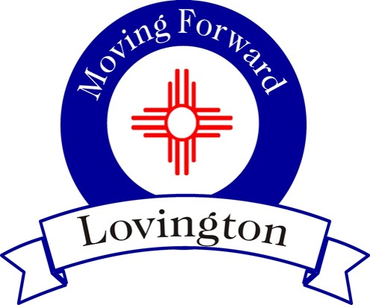

City of Lovington
214 S. Love
Lovington, NM 88260
575.396.2884

Contact: For Immediate Release
James R. Williams June 6, 2016
City Manager 3:00 p.m.
575.396.2884

Mosquito Spraying

(LOVINGTON, NM) – City staff will being spraying for mosquitos inside the City limits on Monday, June 13, 2016. Spraying will occur Monday thru Thursday, between the hours of 7 p.m. and 11 p.m., dependent upon weather conditions. Areas that will be sprayed will follow the same days of regular trash pickup, with the exception of the Thursday and Friday routes that will be combined. Once the first round of spraying is complete, a second round will be conducted. Further spraying will be based on determined need. In addition to spraying, staff will be dispersing briquettes in areas of standing water.

Citizens are encouraged to not block alleyways in order to facilitate spraying. In addition, we ask that containers that may hold water, that will remain undisturbed, be emptied at least every two days and that weeds are removed from properties. With your help, in addition to the spraying, we should be able to greatly reduce the number of mosquitos in our town.

##

